Ancient Olympics – Historical Fiction
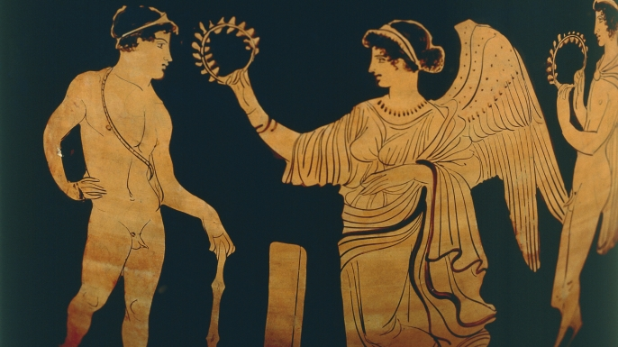

The Task:
You will compose a work of historical fiction, comprising of no less than 2 pages, typed, double spaced, in which you outline the experiences of an athlete participating in the ancient Olympic Games. Group research will be completed on the overall games, though individual research will be required in regards to your choice of your athlete’s home city-state, as well as the specific event in which he is competing.
Specifics:
- Your historical fiction can be composed from the 1st or 3rd person perspective (author’s choice)
- You will chose the city-state from which your athlete hails, in addition to the specific event in which he will compete
- Your writing will need to incorporate at least one piece of information from each of the overall sections of class research (lexicon, A Day at the Games, Athletes and Training, Religion, The Events), as well as specific historical research regarding your city-state and event
The Final Product:
You will submit two copies of the final product, stapled together.
The first (on top) will simply be the final piece of historical fiction, typed and printed. The second will be colour coded (either through word processing or physically done after printing) in order to show what learning was specifically included in your fiction in order to make it “historical”.

