Aspects of Culture – A Global Snapshot
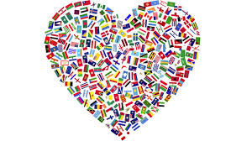
You will be working with a partner in order to create and deliver a presentation that highlights various cultural aspects of a certain country. The presentation must include some sort of visual platform. Please remember that the visuals employed should be largely free of text/information, other than titles. Information given should be from your notes/cards, and only supplemented meaningfully by the visuals. It’s also a great idea to make sure you interact with and explain how your visuals support your information.
- Don’t feel limited to static visuals for your presentation. The use of video clips (as long as they don’t dominate the presentation) can be very effective
The “snapshot” presentation will be marked based on the quality/depth of your information, the visuals/manipulatives employed, and the quality of your verbal presentation (including fluidity and interaction with your partner).
ASPECTS OF CULTURE TO BE EXAMINED:
Aspects that MUST be covered include:
- Laws (with a focus on strange laws)/crime and punishment
  - Murder
  - Rape
- Food/drink
  - Traditional dishes
  - Food that we don’t have in Canada
- Traditions/festivals
- Rights for minority groups (ex. women, LGBTQ, visible minorities)
  - When did women get the right to vote? Is there pay equity, etc.
- Human rights issues and/or climate & environmental issues
- Stereotypes

You will also choose TWO of the following options:
- Traditional clothing
- Musical traditions
- Schooling/Education
- Prevalent minority cultures
- Inventions/contributions to global culture
- Military/involvement in world affairs

