Culturally Me
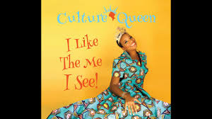
Intent = Define oneself “culturally”
Aspects of research can include:
- Geographical/Cultural heritage, through your immediate parentage
- Cultural traditions manifest in our own lives (stories told, books read a s a kid, etc.)
- Names (meaning and origin story of how you were named)
-Can discuss first, middle, and last names
-Last name is a good indicator of cultural heritage
- Names and cultural expression of family members
- Religious background/outlook
- Affect of cultural on your daily lives
- Looks/dress
- Food at home
- Language and accents

How work will be expressed:
-Oral component of your choosing (share your information somehow)
-Visual component (actual pictures of your life OR internet pictures that are symbolic/representative of your research). Can be done in various ways as well, such as on the ipad/Smartboard, on a bristol board, etc
-Concrete component, if applicable (clothing, items/souvenirs, art, etc.)

Assessment:

T = Depth of Research
A = Visual/Concrete Components
C = Oral expression

