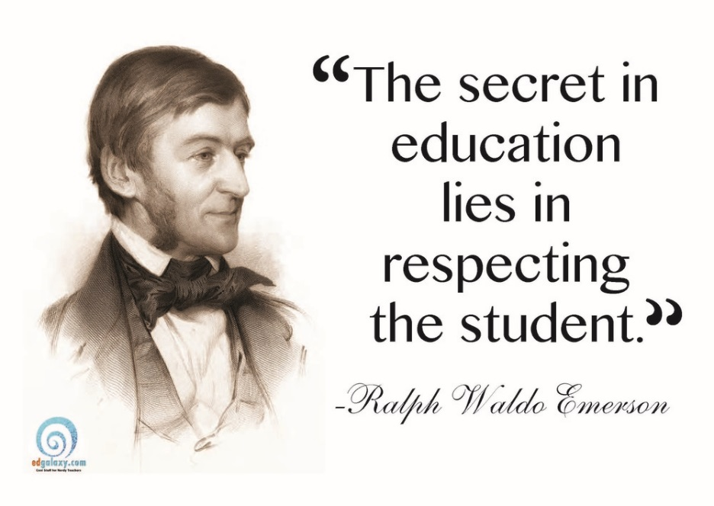
Famous Quotes Assignment
Sequential Instructions for Background Work:
- Choose a famous person (list will be generated with your instructor)

- Research various sayings (quotes) from the person. You will choose ONE (1), which will form the basis for the creative aspect of the assignment

- You need to do some research on the background of your chosen individual. Make a list of 5 points regarding major accomplishments/interesting facts (point form)

Final Product:
- You will create a poster of some kind that displays your chosen quote, as well as the name of the individual who said the quote

This poster should be colourful and creative, and make use of pictures/symbolism regarding the quote or the person (i.e. a poster with a quote from Ernest Hemmingway could have pictures of some of his book covers; a poster about love could be red and have pictures of flowers, cupid, etc.)

These posters will be displayed throughout the class

- Paragraph 1: Using your notes (see #2 above) and proper MLA format, you will compose 1 paragraph regarding the individual you researched. The paragraph should follow the following format:

Sentence #1: Names the person and tells who his is overall. E.g. “Julius Caesar was a Roman general and politician.”

Sentence #2: should start with, “He [she] is a significant figure because [1st point chosen from your notes]”

Sentences #3-#5: Further support from your notes regarding the individual’s significance

Paragraph 2: You will compose a well-structured paragraph detailing why you chose the quote. The answer can look at the quote itself, the subject of the quote (love, wisdom, war, etc.), or a combination of the two

