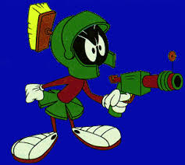
Intro Writing Activity
- You are going to write a long paragraph that tells a story.
- Your paragraph will be a response to these questions.
- Any sentence you write is OK, but you must follow the sequence of questions.
- You can ask me for help while you are writing

- How long have you been on the planet?

- Why did you go there?

- Describe the two people who are with you.

- Why is your spaceship damaged?

- When you decided to leave your ship, how far did you walk?

- What were you looking for?

- When did you realize that someone was following you?

- Describe the creature.

- While you were running away, you tripped and fell. What happened?

- What was the big surprise at the end of your story?

