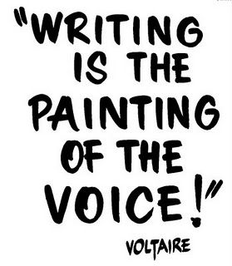
EWC4U/4C – The Writers Craft: Culminating Activity
(30% of Final Grade)

“The Story of Me”

For the final creative writing submission you will compose a metacognitive (reflective) piece outlining your “story” either in this course, or regarding your high school journey overall. This can take any form that you wish (i.e. personal essay, short story, song, poem, visual essay, children’s story, choose your own adventure, etc.).
You may choose your style of narration (first/third person), or even second person (talking to the audience) if you choose a format such as a guide to life in high school at Roland Michener.
Keep in mind your learning regarding the development of character, setting, writing for the senses, developing plot, conflict, etc.
Your submission will be grade using the same format as your other pieces of writing throughout the course.

