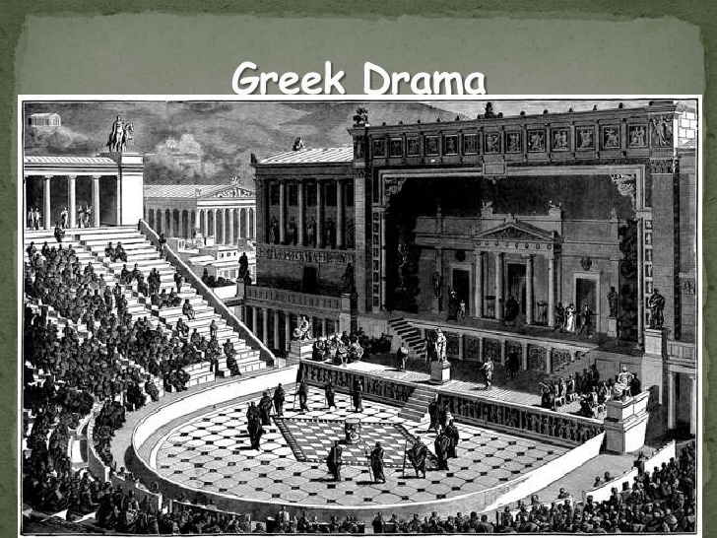

Literature Groups – Dramatic Study Guide
- “About the Playwright”
- Examination of theme
- Plot summary
- Key plot points
- Examination of character(s)
- Historical/mythological backdrop
- Key Quotes & Significance
- Symbolism

Lysistrata – Krcel, Noah, Erica, Ryder
Medea – Blake, Ryah, Hannah
Oedipus Rex – Teagan, Alexander, Adam

