HSC4M – World Cultures: Culminating Activity
Value: 30% of Final Grade
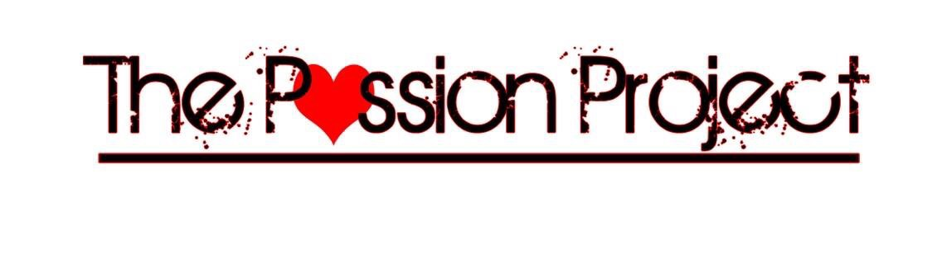
This course will challenge you to identify an issue relating to culture, whether it be on a local, national, or global scale.
Students will choose an area of interest and work over the course of the semester to develop a project that is meaningful to them, and which addresses in some way their chosen issue.
The focus and product will differ, but the goal will be the same: to enlighten, empower, and aid.

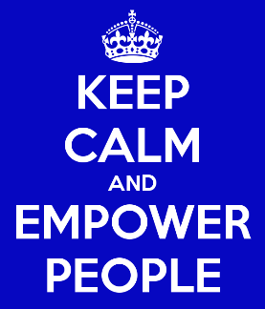
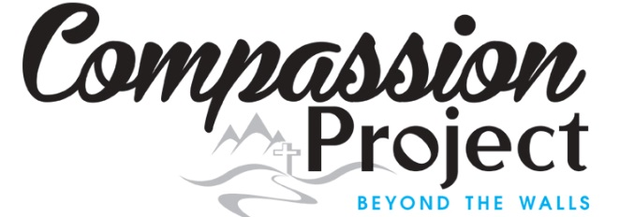

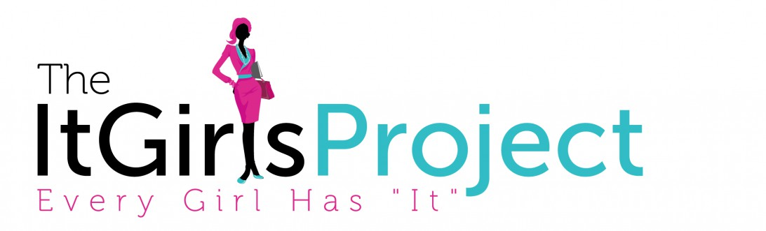

STEPS:

#1 – Generating Ideas: In the first couple of weeks you have been able to see/examine/discuss a multitude of issues related to world culture. Now you need to start thinking about ideas for your own project

#2 - Topic Approval & Inquiry Question: Decide on a Topic and Develop an Inquiry Question a question that can’t just be “Googled”

#3 – Brainstorm potential product ideas

#3 – Passion Project Pitch: You will write out and then present your pitch. The pitch must answer the 3 simple questions – WHAT? WHY? HOW?

#4 – Research and Project Creation

#5 – “Rolling it Out”: Students complete their product

Resources for Inspiration
http://liveyourlegend.net/living-legends-reader-spotlight-5/
https://www.youtube.com/watch?v=xupHuEk8p7g

HSC4M – Passion Project: Final Product
What, Why, How?
Your final product will consist of three facets:
- Awareness: This facet will contain the bulk of your research from the semester, and answer for the audience you have chosen the “What” and “Why” aspects of your project. This facet should be more than a simple Power Point presentation, and focus on creating not only an awareness, but an emotional and mental impact on your target audience. This can be rolled out in a number of ways, and is not limited to one medium (i.e. class-to-class, display information booth in guidance/the lunch room, flyers on car windshields, etc.)
- Making a difference: Your overall focus for the semester was always with the end-goal of “making a difference”. Most often, raising awareness is only a simple first step. Your concrete final product will address the “How” of this product. HOW are you going to make a difference? Fundraising for a cause is a simple end goal, but is not the only one. Research various organizations and how one can make a difference. It could be by donating time to a cause, organizing an event, creating a dramatic skit, running a concert, and any multitude of other options.
- Metacognitive Reflection: Once the project is done you will complete a 2 page reflection that addresses the following sections:
- What went right?
- What went wrong or could have been done better? Why did it go wrong, and/or how could it have been improved?
- Your overall feelings on your Passion Project and the results

Mark Scheme – Passion Project:
Engaging Content /20
Use of Graphics/Visuals /20
Communication (written and oral) /20
Effort Towards Final Product /20
Planning Skills /10
Effective “Roll Out”/Final Product /20

Reflective thought /10
Communication/Layout /10

Total /130

