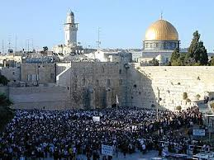

Interesting Facts about The Western Wall

- The site of the Temple is where all Western religions believe Abraham was going to sacrifice Isaac.

- The most sacred part of the Temple, Holy of Holies, is thought to be located beneath the current Dome of the Rock (the exact site is unknown)

- Since the exact site is unknown, most Orthodox Jews will not go on the Temple Mount at all due to fear of stepping on this most holiest of sites.

- Orthodox Jews still follow biblical rules regarding coming near the Temple.

- Women do not come to the Temple during or following their menstrual cycle (have to go through cleansing ritual). Men cannot come after a seminal emission.

- Jews should never show their back to the Temple.

- It is a tradition that when water comes through the stones of the Western Wall it is a sign that the coming of the Messiah is near

- When God removed his essence from the Temple, he placed it upon the Western Wall where it remains today. Therefore, Jews touching the Wall believe when they touch they wall they are interacting will God / feeling God’s essence.

- The central prayer, called the Amidah, is recited three times daily (morning, afternoon, evening). Jews have to face Jerusalem when reciting. More specifically, they have to face the Temple Mount.

- Jewish law says that Jews must grieve and tear their garments before visiting the Western Wall.

- Although the Jews govern Jerusalem itself, the Temple Mount is controlled by the Muslims and the state of Israel has no authority over it, either secular or sacred.

- The notes in the Western Wall are carefully collected twice a year and are then buried in a cave in Mount of Olives.

