“Double, double, toil and trouble” – The Witches’ Brew
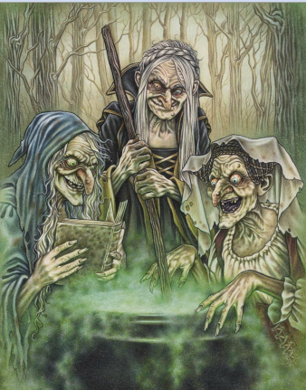

For this assignment you will work in pairs to compose your own “evil charm” magic, akin to the spell performed by the Wyrd Sisters (sisters of fate) in Act 4, Scene 1 of Macbeth.
Success Criteria:
- Writing should be in the Elizabethan, and attempt to follow basic textual structure
- The spell format should follow that of the text, with the spell having at least 3 sections (1/witch)
- Each section should have at least 8-10 specific ingredients
- “Spells” should start with the “Double, double” lines, which should then appear between sections of the spell
- The spell should end with the line, “Cool it with a __________ blood,/Then the charm is firm and good.” (4.1.37-38)
- At least one historical/mythological/literary allusion should be used within the spell
- Special attention should be given to HOW you communicate your spell ingredients. Review the type of language used in the original text. Pay attention to adjectives and other specifics given.
- Your final submission should be made to look “authentic”. Think of creative ways to age the paper, add to it (spider webs, etc.). You may want to complete your final copy on something other than standard paper

