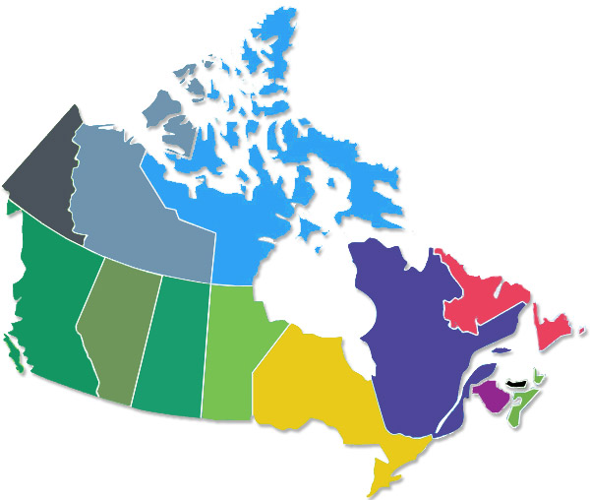
CHC2D – Canadian Map Activity

Instructions:

- Identify the provinces and territories
- Capital cities (provincial and federal). These should be identified on the map itself with a well placed bullet
- Colour the map, using various shades, but NO blue (blue is almost always water on maps)
- Identify the land surrounding Canada (Greenland and the United States)
- Identify Alaska (part of the U.S.)
- Identify the year the province joined Canada
The Map Itself:
- Rough work can be done right on the actual map
- Good copy of the map should be completed using a legend, either on the back of the map or somewhere on the front, if applicable

