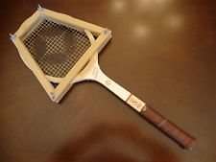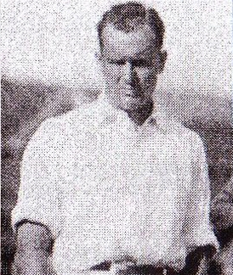
Willard Crocker

Willard Crocker was a well-known Canadian tennis player from 1923-1930. After playing for Davis Cup, and sweeping both Ontario and Quebec provincial titles, Crocker was rated one of the best tennis players in Canadian history.¹
Crocker was away at McGill University, studying medicine and English, when his exceptional tennis playing skills were first recognized.² In 1920, Crocker played and captained for the McGill University team. That same year, he won the Canadian intercollegiate singles and doubles titles. Then, “In 1923, he won the intercollegiate singles title again while serving as team president.”³ In that same year he managed to take Ontario and Quebec provincial titles, and then “won the Canadian indoor singles title and was a finalist at the outdoor championships.”⁴
Crocker and his teammate Jack Wright, from McGill University and Davis Cup, won three Canadian outdoor doubles titles in 1923, 1925, and 1929. Crocker then took the Canadian singles title in 1925. Still on fire, he took the title again in 1929.⁵ Crocker knew how to play the game:“His game was beautiful to watch, always steady but with flashes of brilliant play that indicated he had studied the game from the theoretical side.”⁶ Crocker had made so many accomplishments and from 1926-1929 he was named Canada’s second best player for those four years straight.⁷
Willard Crocker was an exceptional tennis player with amazing playing skills that kept him on the ranks for such a long time. He had won several titles during his career, and is still to this day, remembered for his preeminent tennis playing. After several years of taking titles, he finally made his way into being inducted to the Canadian Tennis Hall Of Fame in 1991.⁸ Overall, Crocker had a life full of achievements and was a great sport.

