Verona Observatore
Bloody brawl rocks streets of Verona
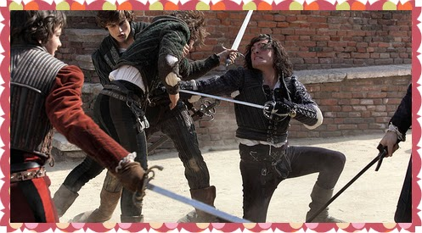
Civil Blood Makes Civil Hands Unclean

