The Greek Gods - Assignment
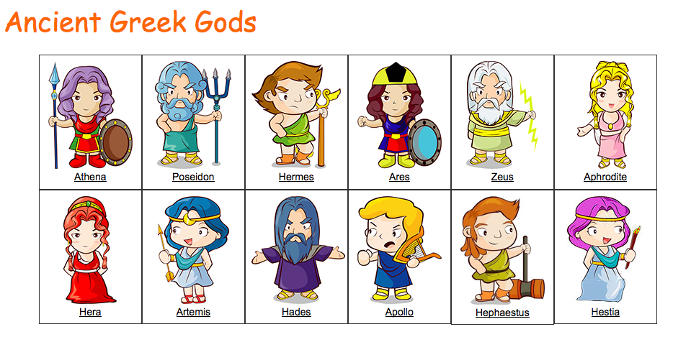
You will be completing a partnered assignment wherein you will research one of the Greek deities gone over in class yesterday (i.e. The 12 Olympians. Well, ok, 14…)
For the assignment, please execute the following steps:
Step 1: Once you have determined your partner, access the teacher in order to choose the deity you wish to research
Step 2: You will complete an “information poster” about your chosen deity. I am leaving a visual outline of what your completed poster should look like on the side board of the class. The poster can be completed on a regular 8X11 sheet of paper (i.e. a plain white piece of printer paper). It can be completed either by copying and pasting images/text into a Word document OR on an app on your ipad
Your information poster MUST include:
- The Name of the deity, prominently portrayed at the TOP of the page
- His/her sphere of influence, prominently portrayed at the BOTTOM of the page
- THREE distinct sections (1 – General Information, 2 – Symbols and Symbolism, 3 – Fun Facts)
- At least 3 pictures (1 for each section)
- POINT FORM bullets of simple information for each section (5 bullets/section = 15 total). An information poster should be quick to read and offer easy-to-digest information. Avoid longer blocks of text.
Step 3: Once the poster in done, you need to find a story that involves your deity in some way. They might not be the main protagonist in the story, but must at least feature prominently.
Step 4: With your partner, read through the story, creating a POINT FORM synopsis of the tale. Type this up, using proper MLA format
Step 5: Upon my return, you and your partner will be presenting your information poster and the story synopsis. One of you will present one, and the other partner, the other.
TO BE MARKED:
- The information poster
- The typed up synopsis of the story
- The oral communication of the poster/story

