Canadian Cultural Controversy – Justin Trudeau and “Brownface”
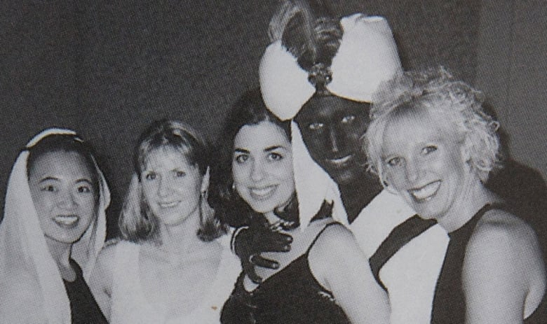
Steps:
- During this period, you will individually amass information on the currently controversy surrounding our prime minister. As you read/watch source material, you will take point form notes on both pertinent facts, as well as thoughts you have on the issues as you go over the information
- You will choose a “discussion partner”. With this other person, you will share your notes/thoughts on the issue, adding to your own notes based on what is presented to you by your partner
- After this partnered discussion is complete, you will compose a reflective writing piece with the following sections:

- Your current thoughts on the issue
- The thoughts of your “discussion partner”

- Following this, you will head back to the internet, focusing specifically on chat board messages/comments on various social media sites. Notes should be taken at this stage as well. Particular attention should be paid to comments made by people of colour. How does their perspective differ from or support your initial assertions?
- There will be a whole class discussion at this point
- You will add to your original writing piece, which will include 2 new sections:

- Discussion of your chat-board/comment read & your opinion now
- How might you feel if you were a person of colour (My perspective if I lived in their shoes)?

