HSC4M – Independent Unit

Students will create and execute a self-directed unit of study. Topics available are almost endless, as long as they are approved by the instructor, and need to reflect an aspect of the HSC4M curriculum (expression of culture, art/religion/philosophy/policy and issues/power and relations, etc.)
Students will complete a total of 3 assessments within the unit – 1 major assessment, and 2 minor assessments.
In addition, all students will submit a bibliography of sources used, as well as a folio off all of their research materials (printouts, hand-written notes, graphs, pictures, etc). Folios will be provided.

Assignments will be composed of a combination of the following components:
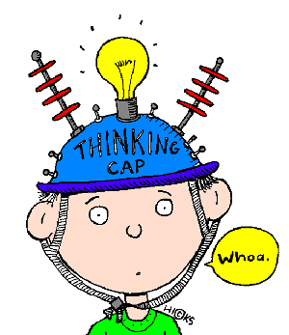
*Written component
*Oral Component
*Research Component
Creative Component
Technological Component
Metacognitive Component
Collaborative Component

Assignment Options
Major Assignment Options:
- Handbook/Guidebook
- Essay
- Speech
- Seminar
- Documentary/mockumentary
- Song writing/performance
- Board game
- Game Show
- Cartoon
- Dramatic presentation/reading
- Debate
- Lecture
Minor Assignment Options:
- Visual Timeline
- Brochure
- Poster
- Newspaper Article/Report
- Trading Cards
- Mind Map
- Blackout Poem (or other styles of poetry)
- Trivia
- Political Cartoon
- Commercial
- Prezi
- Blog
- Collage

Flex Options (dependent on the scope – TBD by student/instructor):
- Journal/diary Entry
- Choose your own adventure
- Manifesto (politically or ethically changed speech)
- Comic Strip
- Scrapbook
- Instructional Video
- Q & A

